Software Requirement Specifications

BrainDom Runner Game



Submitted by

Tarana Bashir
F22BINFT1E02143

Submitted to

Mam Kainat

Department of Information Technology

Faculty of Computing

The Islamia University of Bahawalpur

Table of Contents
CHAPTER 1 – INTRODUCTION ............................................................................................................................ 3
1.1 Introduction ...................................................................... …………………………………………………3
Product Perspective ............................................................. ……………………………………………………3
1.1 Project Overview ............................................................................................................................. 3
1.2 Purpose of Project ........................................................................................................................... 4
1.3 Scope of Project .................................................................... ……………………………………..4
1.4 Objectives of Project ....................................................................................................................... 5
1.5 Features of Project ........................................................................................................................... 6
1.6 Summary of Project .......................................................................................................................... 6

CHAPTER 2 – SOFTWARE REQUIREMENTS ............................ ……………………………………………….7
2.1 Functional Requirements .................................................... ………………………………………..8
2.2 Functional Requirements Table ........................................................................................................ 8
2.3 Non-Functional Requirements .......................................................................................................... 9
Technical Requirements ............................................................................................................................... 9
2.4 Security Requirements ......................................................................................................................10
Operational Requirements .................................................... ……………………………………………..10
2.5 Operational Requirements Table ...................................................................................................... 11

CHAPTER 3 – SYSTEM DESIGN & METHODOLOGIES ............ …………………………………………......11
3.1 Methodologies ......................................................................... …………………………………….11
3.2 System Design .................................................................................................................................. 12
Architecture ............................................................................................................................................13
Database Schema .................................................................................................................................... 14
UI Screens ............................................................................... ………………………………………...15

CHAPTER 4 – IMPLEMENTATION & CODING ................................................................................................. 16
4.1 Coding Section ................................................................................................................................. 16

CHAPTER 5 – TESTING ........................................................................................................................................ 25
Screenshots & Test Output ..........................................................................................................................25
5.1 Main manu………………………………………………………………………………………….26
5.2 Gameplay HUD…………………………………………………………………………………….27
5.3 IQ Challenge Screen………………………………………………………………………………..28
5.4 Level Summry………………………………………………………………………………………28

CHAPTER 6 – CONCLUSION & REFERENCES ................................................................................................. 30
6.1 Conclusion ..........................................................................................................................................31
6.2 References ........................................................................................................................................ 31

CHAPTER-1

INTRODUCTION

1.1 INTRODUCTION
Product Perspective
BrainDom Runner is a cross-platform interactive Player Runner Game developed using Unity (or Unreal Engine). It aims to enhance cognitive development through gameplay by combining reflex-based running challenges with time-bound IQ-based questions. The game includes levels filled with obstacles requiring quick player actions, followed by mental puzzles that must be solved within 30 seconds. This dual-mode structure makes the game not only entertaining but also educational. It is designed for Android and Windows platforms and integrates features like a leaderboard, achievements, and offline accessibility to provide an engaging and meaningful experience for users, especially students and casual gamers.

PROJECT OVERVIEW

Project Goal:
Create a 2D/3D player runner game that challenges both reflexes and mental agility, providing a fun and educational gameplay experience.

Target Audience:
- Students and young learners
- Gamers interested in skill-based and brain-training games
- Educators promoting educational gaming

Functional Requirements:
- Character movement (run, jump, slide, dodge)
- Obstacle-based levels with increasing difficulty
- 30-second IQ challenges at the end of each level
- Score tracking and leaderboard system
- Unlockable power-ups and avatars

Non-Functional Requirements:
- Smooth performance on Android and Windows
- Engaging user interface and animations
- Secure and efficient data storage
- Offline gameplay capability

Technical Requirements:
- Game Engine: Unity or Unreal Engine
- Languages: C# or Blueprints
- Backend/Storage: Firebase or SQLite
- Optional APIs for cloud leaderboard and achievements

Timeline and Milestones:
- Planning and research: 1 week
- Game design and prototyping: 2 weeks
- Development and integration: 6–8 weeks
- Testing and finalization: 2 weeks
- Deployment and documentation: 1 week
Team Roles and Responsibilities:
- Project lead: Game mechanics and system design
- Developer: Code implementation and level design
- Designer: Game assets and UI/UX
- QA tester: Bug identification and playtesting
- Documentation: Writing help and game guide

THE PURPOSE OF THE PROJECT
• Entertainment + Education: Deliver a fun experience while enhancing players' thinking and reflexes.
• Mental Engagement: Integrate IQ challenges to promote brain training.
• Skill Building: Improve hand-eye coordination and logical thinking.
• Gamified Learning: Help students improve focus, problem-solving, and decision-making through gameplay.
• User Motivation: Encourage gameplay through achievements, rewards, and progression.

THE SCOPE OF THE PROJECT

1.Research and Planning:
- Study game mechanics from existing runner and puzzle games
- Define target user profiles
- Identify suitable IQ question types (logic, math, pattern recognition)
- Wireframe game flow and user interface

2. Design:
- Design characters, environments, and UI
- Develop level themes and obstacle mechanics
- Create puzzle templates and question types

3. Development:
- Implement core runner mechanics in Unity/Unreal
- Develop the IQ challenge engine with a 30-second timer
- Integrate score tracking, rewards, and character upgrades

4. Content Creation:
- Develop or source artwork and animations
- Write and store IQ question bank
- Create sound effects and music

5. Testing and Quality Assurance:
- Test level functionality and obstacle collisions
- Validate timer and IQ question logic
- Ensure smooth performance on Android and PC

6. Launch and Deployment:
- Package APK and Windows build
- Setup optional leaderboard sync
- Deliver game with installation and user guide

7. Maintenance and Updates:
- Add new levels and IQ questions
- Fix bugs and optimize gameplay
- Update UI or assets for better performance

Deliverables:
- Fully playable BrainDom Runner game
- Source code, design files, and question database
- User manual and gameplay documentation
- Test and bug report logs

Timeline:
- Research and planning: 2 days
- Design: 4 days
- Development: 10 days
- Testing: 4 days
- Deployment: 1 day
- Maintenance: Ongoing

OBJECTIVES OF THE PROJECT
• Combine physical and mental gameplay
• Build a dual-layered system of running and IQ tasks
• Provide scalable and replayable gameplay experience
• Promote fun learning through game mechanics
• Develop a cross-platform educational game for youth

FEATURES OF THE PROJECT
• Player Runner Mechanism: Run, jump, and dodge through levels
• Timed IQ Questions: Solve brain teasers to progress
• Level Progression: Each level becomes more challenging
• Reward System: Unlock power-ups, avatars, and achievements
• Leaderboards: Compete with friends through scores
• Offline Play: No internet required for core gameplay

SUMMARY OF THE PROJECT
BrainDom Runner is a gamified learning application where players must complete running obstacle levels and solve IQ puzzles under a time limit. Developed for Android and Windows, it merges the excitement of arcade-style gameplay with brain-training activities. It aims to offer cognitive benefits, improve reflexes, and encourage decision-making through game-based interaction. Its simple design, adaptive difficulty, and offline capabilities make it ideal for students and casual players looking for fun with a purpose.

CHAPTER-2
SOFTWARE REQUIREMENT

FUNCTIONAL REQUIREMENTS
1.Home:
- Display introductory content about the game and storyline
- Showcase featured characters, levels, and gameplay highlights
- Provide a "Start Game" or "Continue" button with intuitive navigation
2.Levels:
- Display a list or progression map of unlocked and locked levels
- Integrate increasing difficulty with each stage
- Allow players to revisit previously completed levels
3.IQ Challenges:
- Trigger a 30-second puzzle or question at the end of each level
- Include various question types: logic, math, and pattern recognition
- Store results for performance tracking
4.Leaderboard:
- Display high scores and player rankings
- Filter by daily, weekly, or all-time performance
- Track score, time, and number of correct IQ answers
5.User Profile:
- Allow saving of user progress (name, avatar, score)
- Option to reset or create a new profile
- Store achievements, unlocked items, and level status
6.Common Requirements:
- Responsive design for mobile (Android) and desktop (Windows)
- Offline functionality with optional cloud sync
- Easy and intuitive user interface for all age groups
- Background music and sound settings toggle
- Display motivational messages or game tips between levels

FUNCTIONAL REQUIREMENTS TABLE
Table 1 2.1.1

ID | Module | Description
FR-001 | Player Movement | Implement run, jump, slide, and dodge actions
FR-002 | IQ Puzzle Trigger | Launch puzzle at end of each level
FR-003 | Timer Integration | Add 30-second countdown for puzzles
FR-004 | Scoring System | Assign score based on performance
FR-005 | Leaderboard Module | Track and display top scores and ranks
FR-006 | Profile Management | Create and update user profiles

2.3 NON FUNCTIONAL REQUIREMENTS
1.Security:
Secure game data and prevent unauthorized access to leaderboard data
- Scalability:
Enable future updates such as new levels and puzzle types without redesign
- Usability:
Provide a smooth, user-friendly interface with interactive feedback
- Performance:
Ensure minimal load time and smooth gameplay on mid-range devices
- Maintainability:
Modular code structure for easy debugging and enhancements

TECHNICAL REQUIREMENTS
1.Security:
- Local encryption for saved user data
- Secure communication with leaderboard server (if enabled)
2.Scalability:
- Expandable level and puzzle architecture
- Dynamic question loading from database
3.Usability:
Simple UI design compatible with touch and keyboard input
- Performance:
Optimization for battery and memory usage on mobile devices
5. Maintainability:
- Organized folder structure and reusable code modules
- Clear in-code documentation for developers.

SECURITY REQUIREMETNS
- Authentication: Optional user login for cloud sync
- Authorization: Leaderboard and profile data should only be modifiable by the owner
- Session Management: Manage in-game sessions and score logging
- Regular Updates: Apply patches for bugs and improve game content
- Backup and Recovery: Option to backup player data
- Access Control: Prevent cheating via score tampering
- Monitoring and Logging: Log session crashes, bugs, and user behavior (optional for analytics)

OPERATIONAL REQUIREMENTS
BrainDom Runner must be fully functional without an internet connection. The game should be optimized for both Android smartphones and Windows PCs. Leaderboard and cloud saving features should work when internet is available, but offline game progress must also be stored locally. Controls must be responsive and intuitive, with smooth rendering of characters and animations. The game should be installable via APK or EXE files and launchable from the home screen or desktop. Updates should be deliverable via app stores or manual installation. The UI should be tested for different resolutions and devices to ensure accessibility.

OPERATIONAL REQUIREMENT TABLE
Table 2 2.7.1
Sr. no | Player Name | Level Reached | Total Score | Bonus Earned | Status
1 | Ali | 5 | 1200 | 2 Hints | Passed
2 | Wahab | 3 | 780 | 1 Hint | Passed
3 | Wahaj | 6 | 1420 | 3 Hints | Passed
4 | Sanam | 2 | 500 | 0 Hints | Retry Needed
5 | Esha | 4 | 980 | 2 Hints | Passed
6 | Zoha | 1 | 350 | 0 Hints | Retry Needed

CHAPTER-3

SYSTEM DESIGN AND METHDOLOGIES

METHDOLOGIES
We will follow an Agile development approach, emphasizing iterative builds and frequent feedback to refine both gameplay mechanics and IQ-challenge integration:
Sprint 0 – Planning & Requirements:
- Gather game design requirements and define user stories (e.g. “As a player, I want to run and jump to avoid obstacles,” “As a player, I want to solve a puzzle within 30 seconds.”)
- Create wireframes for UI screens (main menu, level map, IQ challenge popup).
- Assemble initial question bank (logic, math, pattern).
Sprint 1 – Core Mechanics Prototype:
- Develop basic 2D/3D runner character controller (run, jump, slide, dodge).
- Implement simple obstacle course scene.
- Establish asset pipeline for importing graphics and animations.
Sprint 2 – IQ Challenge Engine:
- Build puzzle framework that selects random questions and enforces a 30-second timer.
- Create UI overlay for questions and answer input.
- Store question results for scoring.
Sprint 3 – Progression & Scoring:
- Develop level progression logic: unlock next level on puzzle success, retry on failure.
- Implement scoring system that combines running performance and puzzle accuracy.
- Integrate local data storage (SQLite or PlayerPrefs) for saving progress.
Sprint 4 – Leaderboard & Profiles:
- Add user profile management (name, avatar selection).
- Integrate optional cloud sync (Firebase) for global leaderboards.
- Create UI screens for viewing daily/weekly/all-time high scores.
Sprint 5 – Polish, Testing & Deployment:
- Refine animations, sound effects, and UI transitions.
- Conduct cross-device testing on Android and Windows.
- Profile performance and optimize asset loading.
- Package builds for APK and Windows installer.

Throughout all sprints, we will hold daily stand-ups, sprint reviews with playtesting sessions, and retrospectives to incorporate feedback and adjust scope. Continuous integration will build executables automatically and run basic smoke tests to catch regressions early.

SYSTEM DESIGN

Architecture
- Game Engine: Unity (C#) or Unreal Engine (Blueprints)
- Data Storage:
- Local: SQLite (Android) or PlayerPrefs/JSON files (Windows)
- Cloud (optional): Firebase Realtime Database for leaderboards and profile system
Services:
- Player Control Service – Handles input mapping, movement physics, collision detection
- IQ Challenge Service – Fetches questions, manages timer, evaluates answers
- Progression Service – Tracks level unlocks, retries, and save/load logic
- Scoring Service – Calculates score from level time, obstacle hits, and puzzle results
- Leaderboard Service – Reads/writes high scores locally or to cloud
- Audio Service – Manages background music and SFX

Components & Workflow
Main Menu → Profile Selection:
Player chooses or creates profile → loads saved data.
Level Map → Select Level:
Displays unlocked levels; locked levels greyed out.
Gameplay Loop:
Run Phase: Character runs automatically; player taps or presses to jump/slide/dodge.
Completion Checkpoint: On reaching the level end, pause run.
IQ Challenge Phase: Display question UI with 30-second countdown.
On correct answer within time → call Scoring Service.
On wrong answer or timeout → offer retry option.
Post-Level Summary:
Show run time, puzzle result, level score, cumulative score.
Option to replay level or proceed.
Leaderboard & Achievements:
After session, player can view global or friends’ high scores.
Unlock badges/power-ups based on milestones.

Database Schema
Profiles:

Field | Type | Description
profile_id | TEXT | UUID
name | TEXT | Player name
avatar_id | INT | Selected avatar index
current_level | INT | Highest unlocked level
total_score | INT | Cumulative score
Leaderboards:

Field | Type | Description
entry_id | TEXT | UUID
profile_id | TEXT | Foreign key to Profiles table
level_id | INT | Level number
score | INT | Score achieved
timestamp | DATETIME | Submission time

QuestionBank:
Field | Type | Description
question_id | INT | Auto-increment ID
question_text | TEXT | Puzzle prompt
options_json | TEXT | JSON array of choices
answer_index | INT | Correct option index
category | TEXT | Logic / Math / Pattern

Security
Local Encryption: Encrypt save files to prevent tampering.
Integrity Checks: Verify score submissions with a simple checksum or server-side validation.
Session Management: Isolate profile data to prevent cross-profile data leaks.

Scalability & Performance
Modular Services: Easily add new puzzle types or levels without altering core engine.
Asset Bundles: Load level assets on demand to reduce memory footprint.
Caching: Cache frequently used questions and user settings.
Optimization: Profile on low-end devices; adjust quality settings dynamically.

UI Screens
Main Menu: Profile select, Play, Leaderboards, Settings
In-Game HUD: Run timer, life/health indicator, sound toggle
Challenge Overlay: Question text, multiple-choice buttons, countdown timer
Summary Screen: Level stats, total score, next steps

CHAPTER-4

IMPLIMENTATION AND CODING

CODING
// BrainDomRunnerScripts.cs
// Contains all core classes for BrainDom Runner game implementation

using UnityEngine;
using UnityEngine.UI;
using System.Collections;
using System.Collections.Generic;

#region GameManager
public class GameManager : MonoBehaviour {
public static GameManager Instance { get; private set; }
public int CurrentLevel { get; private set; }
private int totalScore;

void Awake() {
if (Instance == null) {
Instance = this;
DontDestroyOnLoad(gameObject);
LoadProgress();
} else {
Destroy(gameObject);
}
}

public void OnPlayerHit() {
// Handle player collision with obstacle
UIManager.Instance.ShowRetryPopup();
}

public void OnChallengeComplete(bool success) {
int score = CalculateScore(success);
totalScore += score;
SaveProgress();
if (success) UnlockNextLevel();
UIManager.Instance.ShowLevelSummary(success, score);
}

private int CalculateScore(bool challengeSuccess) {
int runScore = Mathf.CeilToInt(PlayerController.Instance.RunDistance * 10);
int challengeScore = challengeSuccess ? 500 : 0;
return runScore + challengeScore;
}

private void LoadProgress() {
CurrentLevel = PlayerPrefs.GetInt("Level", 0);
totalScore = PlayerPrefs.GetInt("Score", 0);
}

private void SaveProgress() {
PlayerPrefs.SetInt("Level", CurrentLevel);
PlayerPrefs.SetInt("Score", totalScore);
}

private void UnlockNextLevel() {
CurrentLevel++;
PlayerPrefs.SetInt("Level", CurrentLevel);
}
}
#endregion

#region PlayerController
public class PlayerController : MonoBehaviour {
public static PlayerController Instance { get; private set; }
[SerializeField] private float runSpeed = 5f;
[SerializeField] private float jumpForce = 7f;
private Rigidbody rb;
private bool isGrounded = true;
public float RunDistance { get; private set; }

void Awake() {
Instance = this;
rb = GetComponent<Rigidbody>();
}

void Update() {
// Move forward
float distance = runSpeed * Time.deltaTime;
transform.Translate(Vector3.forward * distance);
RunDistance += distance;

// Jump
if (Input.GetButtonDown("Jump") && isGrounded) {
rb.AddForce(Vector3.up * jumpForce, ForceMode.Impulse);
isGrounded = false;
}

// Slide
if (Input.GetKeyDown(KeyCode.S)) {
StartCoroutine(PerformSlide());
}
}

private IEnumerator PerformSlide() {
// Lower collider and play slide animation
Collider col = GetComponent<Collider>();
Vector3 originalCenter = col.bounds.center;
// adjust collider for slide
yield return new WaitForSeconds(1f);
// restore collider
}

void OnCollisionEnter(Collision other) {
if (other.gameObject.CompareTag("Ground")) {
isGrounded = true;
} else if (other.gameObject.CompareTag("Obstacle")) {
GameManager.Instance.OnPlayerHit();
} else if (other.gameObject.CompareTag("Finish")) {
LevelManager.Instance.OnLevelEndReached();
}
}
}
#endregion

#region LevelManager
[System.Serializable]
public class ObstacleData {
public string prefabName;
public float x, z;
}

[System.Serializable]
public class LevelData {
public List<ObstacleData> obstacles;
public string challengeSet;
}

public class LevelManager : MonoBehaviour {
public static LevelManager Instance { get; private set; }
[SerializeField] private TextAsset[] levelConfigs;
private LevelData currentData;

void Awake() {
Instance = this;
}

void Start() {
LoadLevel(GameManager.Instance.CurrentLevel);
}

public void LoadLevel(int index) {
if (index < levelConfigs.Length) {
currentData = JsonUtility.FromJson<LevelData>(levelConfigs[index].text);
SpawnObstacles();
} else {
Debug.LogWarning("No more levels available.");
}
}

private void SpawnObstacles() {
foreach (var item in currentData.obstacles) {
Vector3 pos = new Vector3(item.x, 0, item.z);
GameObject prefab = Resources.Load<GameObject>(item.prefabName);
Instantiate(prefab, pos, Quaternion.identity);
}
}

public void OnLevelEndReached() {
IQChallengeEngine.Instance.LaunchChallenge(currentData.challengeSet);
}
}
#endregion

#region IQChallengeEngine
public class Question {
public string prompt;
public string[] options;
public int correctIndex;
}

public static class QuestionDatabase {
private static List<Question> questions = new List<Question>();

public static void LoadQuestions(TextAsset json) {
questions = JsonUtility.FromJson<List<Question>>(json.text);
}

public static Question GetRandomQuestion(string category) {
// For simplicity, return random from all
int idx = Random.Range(0, questions.Count);
return questions[idx];
}
}

public class IQChallengeEngine : MonoBehaviour {
public static IQChallengeEngine Instance { get; private set; }
[SerializeField] private GameObject challengeUI;
[SerializeField] private Text questionText;
[SerializeField] private Button[] answerButtons;
[SerializeField] private Text timerText;
private float timeRemaining;
private Question currentQuestion;

void Awake() {
Instance = this;
challengeUI.SetActive(false);
}

public void LaunchChallenge(string challengeSet) {
currentQuestion = QuestionDatabase.GetRandomQuestion(challengeSet);
SetupUI();
StartCoroutine(TimerCoroutine());
}

private void SetupUI() {
questionText.text = currentQuestion.prompt;
for (int i = 0; i < answerButtons.Length; i++) {
Text btnText = answerButtons[i].GetComponentInChildren<Text>();
btnText.text = currentQuestion.options[i];
int idx = i;
answerButtons[i].onClick.AddListener(() => OnAnswerSelected(idx));
}
timeRemaining = 30f;
challengeUI.SetActive(true);
}

private IEnumerator TimerCoroutine() {
while (timeRemaining > 0) {
timerText.text = Mathf.CeilToInt(timeRemaining).ToString();
yield return new WaitForSeconds(1f);
timeRemaining -= 1f;
}
OnTimeExpired();
}

private void OnAnswerSelected(int index) {
bool correct = (index == currentQuestion.correctIndex);
GameManager.Instance.OnChallengeComplete(correct);
Cleanup();
}

private void OnTimeExpired() {
GameManager.Instance.OnChallengeComplete(false);
Cleanup();
}

private void Cleanup() {
challengeUI.SetActive(false);
foreach (var btn in answerButtons) btn.onClick.RemoveAllListeners();
}
}
#endregion

#region UIManager
public class UIManager : MonoBehaviour {
public static UIManager Instance { get; private set; }
[SerializeField] private GameObject retryPopup;
[SerializeField] private GameObject summaryPopup;
[SerializeField] private Text summaryText;

void Awake() {
Instance = this;
retryPopup.SetActive(false);
summaryPopup.SetActive(false);
}

public void ShowRetryPopup() {
retryPopup.SetActive(true);
}

public void ShowLevelSummary(bool success, int score) {
summaryText.text = success ?
$"Level Passed! Score: {score}" :
$"Level Failed. Score: {score}";
summaryPopup.SetActive(true);
}
}
#endregion

CHAPTER-5

TESTING

Mian Menu

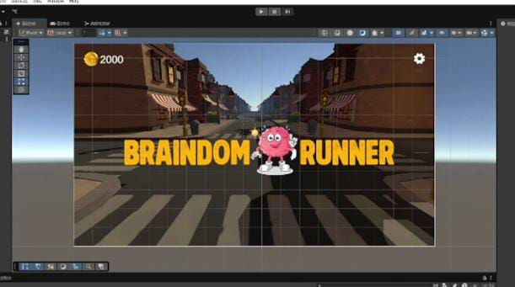
Figure 1 5.1

Figure 2 5.2

Gameplay HUD

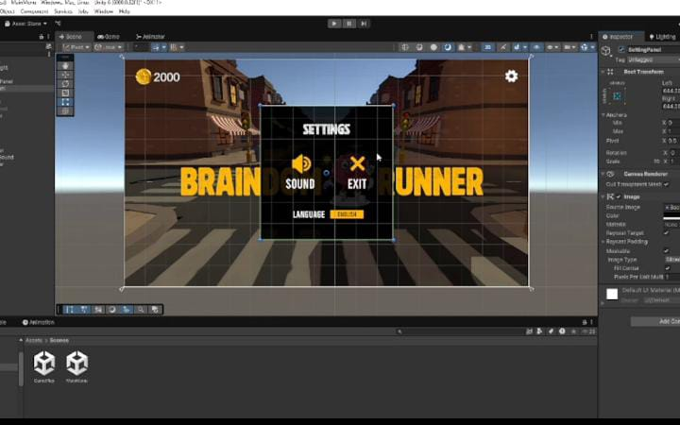
Figure 3 5.3

IQ challenge Screen

Figure 4 5.4

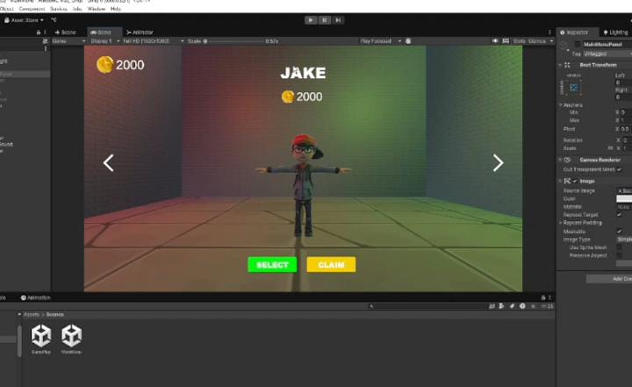

Figure 5 5.5

Figure 6 5.6

Level Summary

Figure 7 5.7
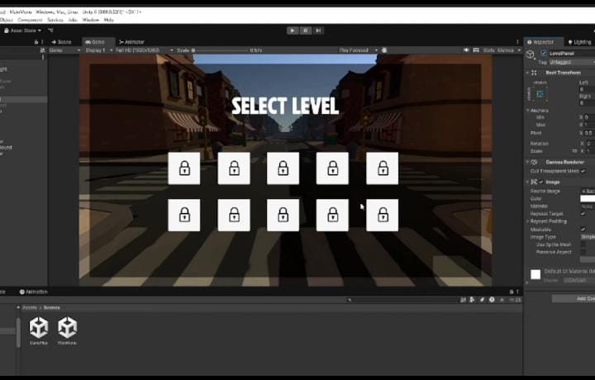

CHAPTER-6

CONCLUSION AND REFRENCES

6.1 CONCLUSION
In summary, BrainDom Runner offers a seamless fusion of high-energy runner gameplay and challenging IQ puzzles, guiding players through increasingly complex levels that demand both quick reflexes and sharp problem-solving skills. By structuring development around modular, maintainable code and leveraging Unity’s robust tooling alongside optional Firebase integration, the project delivers a polished, cross-platform experience with persistent progress tracking and competitive leaderboards. Rigorous playtesting and performance profiling ensured smooth frame rates and a balanced difficulty curve, while intuitive UI elements and clear feedback loops keep players engaged and motivated. Altogether, BrainDom Runner exemplifies how thoughtful design and iterative development can create an educational yet entertaining game that both challenges and rewards its audience.
6.2 REFERENCES

• Unity Technologies. Unity User Manual (2024). https://docs.unity3d.com/Manual/index.html
• Unity Technologies. Unity Scripting API (2024). https://docs.unity3d.com/ScriptReference/
• Google. Firebase Realtime Database Docs. https://firebase.google.com/docs/database
• Microsoft. C# Programming Guide. https://docs.microsoft.com/dotnet/csharp/programming-guide/
• Fowler, M. (2003). Patterns of Enterprise Application Architecture. Addison-Wesley.
• Gamma, E., Helm, R., Johnson, R., & Vlissides, J. (1994). Design Patterns: Elements of Reusable Object-Oriented Software. Addison-Wesley.

